Maybank
Kuala Lumpur, Malaysia

Version 1.0

Author: - Barnabe CARLE

Revision History (Thomson Reuters)
Name | Date | version | Summary of changes
Barnabe Carle | 10/05/2011 | 1.00 | Initial version

Review History (MayBank)
Reviewer Name | Doc Version Reviewed | Date Sent for review | Date Review Filed | Approved/Rejected  (with Reasons)

Table of Contents
About this document 4
Chapter 1 : General Description of the Report Functionalities 5
Chapter 2 : Detailed Description of the Report Functionalities 6
2.1 Decription Input Parameters 6
2.2 P&L Summary View 6
2.3 P&L DetaiL View 8
Chapter 3 : Report Design 11
3.1 High Level Report Flow Description 11
3.2 Underlying Procedures and Tables 11
Chapter 4 : Implementation Steps 14

About this document

This document explains the specifications of the P&L report developed for the Fixed Income desk of Maybank-KL to follow up the Bond P&L based on the Constant Yield methodology currently used on the BO side and using a FIFO Inventory method.
It is also designed to report the Papers PnL based on FIFO Inventory method and linear amortization methodology
The reporting functionalities described in this document are based on the requirements definition communicated between Maybank Fixed Income Desk and Thomson Reuters.
This specification might be subject to addendum or modifications to keep up with any adjustment that might be done on the report. Thus it will be deemed a good description of the existing report only once signed off by Maybank KL and as of this date only.
Departments involved:
- Maybank – KL : Fixed Income Desk
- Maybank – KL : Back Office

: General Description of the Report Functionalities

The report provides a summary and the decomposition of the P&L values for Bonds and Papers calculated based on the constant Yield methodology for bonds and linear amortization methodology for Papers and using the FIFO Inventory method .

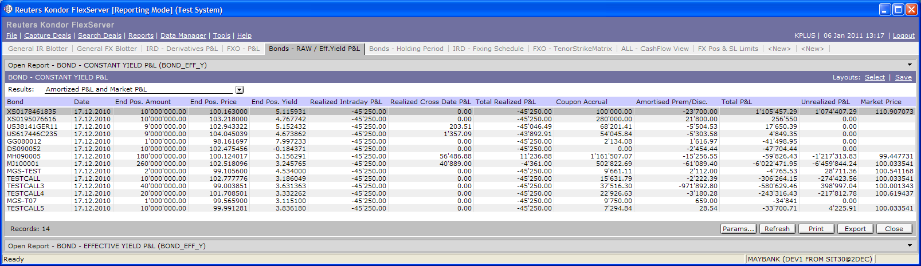

There are only two report views:
- A summary view providing on a folder / Security basis the P&L components between start and end date that have been specified as input parameters
- A detailed view providing the breakdown, on a deal by deal basis, of the PnL since the inception of each position until the end date specified by the user. This breakdown also provides a detail view of the FIFO realized PnL for each position. Note that the PnL in this view, if added up on the deals, might not match with the one in the first view depending on the chosen dates

The report can calculate the P&L for any date in the past retro-actively, provided the correct set of dates is set as input of the report. Note that this PnL doesn’t take into account the cutover process in kplus.

The report can run in Kondor+ as well as in Kondor-FlexServer. In Kondor-FlexServer the user can easily change the layout of the report by hiding or sorting columns, grouping lines and adding formulas (totals, average,...). Several layouts can be built from the same report output and stored.

: Detailed Description of the Report Functionalities

Decription Input Parameters

Input parameters screen:

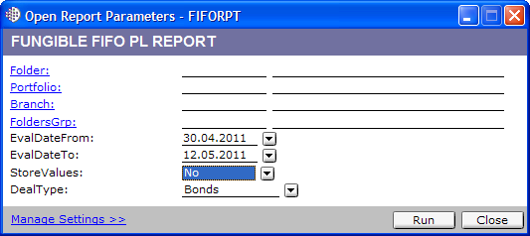

The user can select:
- The hierarchy: Branch, Portfolio, Folder, Folder Group. Even if the hierarchy is not a folder, FIFO methodology will be applied on a folder by folder basis. This is done in order to ensure that summing up the results between perimeter will always yield the same results.
- “Eval Date From” and “Eval Date To”: the report will calculate the P&L within this period. The report is based on a deal by deal PnL and retrieved deals based on the trade date that must be enclosed (report dates included). It will retrieve the initial from start pnl for each deal on start date -1 day and subtract it from the “from start PnL” on End date. PnL begins at beginning of Eval Date From and ends on end of Eval Date To. Result is then a pnl including both start and end date.
- Store Values? If yes the report will store the from start pnl results (on a deal by deal basis) on the end date in a Kustom table. These values can then be used as the initial references for the next period. A specific End of Year choice is available to persist the End Of Year data longer than the report defined 1Y time span for keeping the end of month values.
- Deal type: allows the user to see the reporting on either bonds, papers or both depending on the choice.

P&L Summary View

This summary view provides an overview of the calculated P&L results by bond and paper position on the “evaluation end date”. .
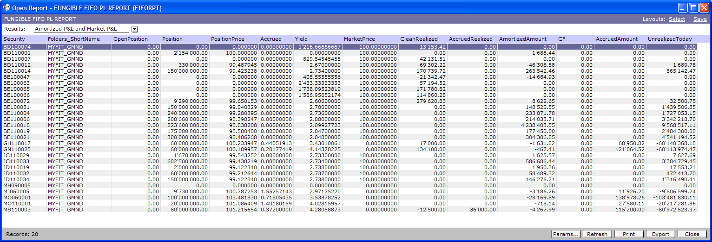

The available columns are:
- Security: name of the security that can be either a bond, a paper or a CD.
- Folders_ShortName: Name of the folder on which the position is considered.
- OpenPosition: Position on Evaluation Start Date.
- Position: Position on Evaluation End Date
- PositionPrice: Price of the position on Evaluation End Date based on the weighted average amortised price of deals included in the position.
- Accrued: accrued on Evaluation End Date. This accrued is the accrued that would be computed for the security on Evaluation End Date according to the value date convention of the security.
- Yield: this yield is the position yield on Evaluation End Date. It is computed for bonds and discounted papers according to the security definition but not for CDs where it is not computed according to the CD definition. The yield will be mostly a yield to maturity except for callable bonds where it will be either a yield to maturity, yield to call or yield to put depending on the setup of the dominant risk on the bond. To compute the yield on the position, each deal included in the position is weighted with its amortized price at this date (end date), and summed up with the other to give a final price for the position. Then the yield will be computed on the position based on this position price.
- MarketPrice: this is the market price used to compute the unrealized part of the PnL. This is the market price on Evaluation End Date + settlement convention of the bond for bonds, and the NPV value as of today of the papers and CDs.
- CleanRealized: this is the realized PnL based on clean buy and sell price only. This doesn’t include the effect of the amortization.
- AccruedRealized: this is the realized PnL based on the accrual of the buy and sell deals. This doesn’t include the coupons that might have been paid between the buy and the sell.
- AmortizedAmount : this is the amortized amount on each deal since the Eval Start date until either sell date or Evaluation End date, whichever happens first
- CF : this is the amount of coupon cashFlow generated by the deal between Eval Start Date and either sell date or Evaluation End Date, whichever happens first
- AccruedAmount : this is the sum of:
  - Accrued Realized
  - CF
  - Accrued unrealized
- UnrealizedToday : this is the clean unrealized based on position amortized price and market price.

P&L DetaiL View

The detail view will provide all details to review the calculations on the different bonds, papers and dates since inception of the first position on the fungible instrument, as explained below.

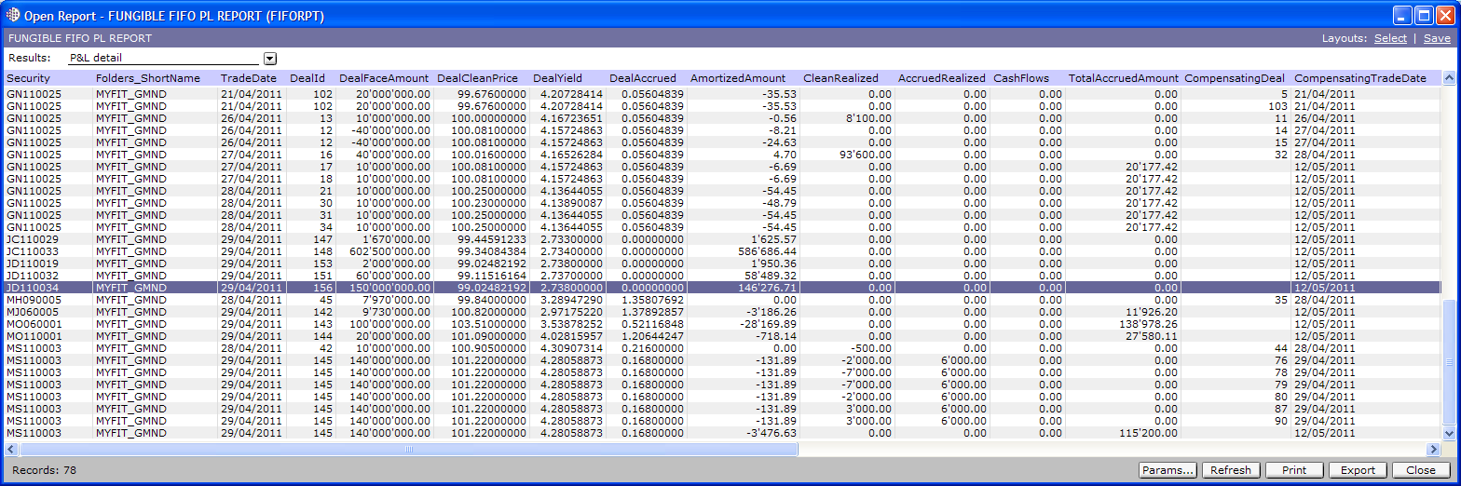

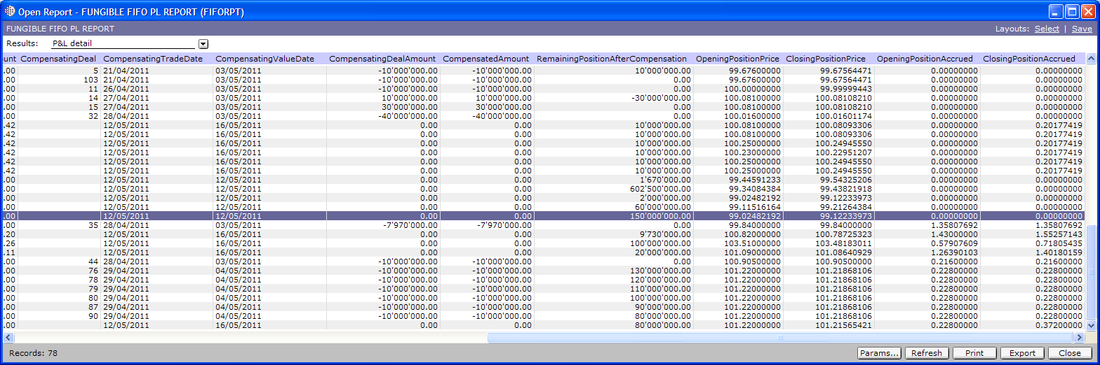

Each line represents the pnl between deal inception and event date on a deal.
Event date can be two things:
- Date at which a position generated by a deal is fully or partially closed: in this case the PnL is 100% realized pnl on the closed part of the position generated by the deal. Amortized figures are still provided from inception date until closing date for the closed amount
- Evaluation End Date : in this case, there will be no realized pnl and amortization as well as accrued will be computed on the open position since inception of the deal until Evaluation End Date
As stated above, PnL in this view is a from start PnL and not only between start and end date

The available columns are:
- Security: Short name in K+ of the bond, paper or CD.
- Folders_ShortName : folder the deal is booked in
- TradeDate : Trade date of the deal
- DealId : deal id of the deal whose position is generating PnL
- DealFaceAmount: original face amount of the deal generating the pnl. Note that this face amount might not be totally taken into account in the pnl of the entry as only the still opened part or closed part of the position is considered for each line (when a deal is partially closed, then at least two entries generating PnL for this deal will be available in the report). Also note that the report handles short positions, so the open position won’t always be positive, depending on the trade history on each folder.
- DealCleanPrice : this is the clean price the deal has been traded at
- DealYield: this is the yield at which the deal has been traded. This yield will be a yield to Maturity except for callable bonds whose dominant risk is next.
- DealAccrued : accrued on the deal at trade date
- AmortizedAmount: this is the amortized amount on the closed position part if the position has been closed or on the outstanding amount
- CleanRealized: This is the realized on the closed part of the position of the deal based on the clean price of deal and closing deal
- AccruedRealized: this is the accrued part of the realized, not including the coupon cash flows
- CashFlows: this is the coupon cash flows related to the remaining position or the closed position and that have been paid between deal trade date and either close position date or Evaluation End Date
- TotalAccruedAmount: this is the sum of :
  - Accrued Realized
  - CashFlows
  - Accrued Unrealized
- CompensatingDeal: this is the deal id of the deal closing (fully or partially) the position created by the deal mentioned in the DealId column. This might be blank if the position is not closed before Evaluation End Date
- CompensatingTradeDate: this is the trade date of the compensating deal
- CompensatingValueDate: this is the value date of the compensating deal. This date is important for the accrual result computation
- CompensatingDealAmount: this is the face amount of the compensating deal. Note that this amount is not the amount closed on the remaining DealId position.
- CompensatedAmount: this is the amount of the open position that will be closed by the compensating deal. This amount can be either:
  - Lower than the CompensatingAmount because the remaining open position generated by the specific DealId is lower than the compensatingDealAmount. In this case, after this step :
    - Either the open position sign stays the same. In this case, a new deal will be compensated by the compensating deal
    - Or the position sign changes and in this case the compensating deals becomes the deal generating the open position and thus becomes, for its remaining non closed amount, the compensated deal
  - Equal to the compensating deal amount : in this case, the remaining open position is equal or greater to the closing deal face amount
- RemainingPositionAfterCompensation: this is the non closed part of the position after part of the position generated by the deal has been closed by the compensating deal
- OpeningPositionPrice: this is the price at which the deal has been traded
- ClosingPositionPrice: this is the amortized price of the deal, computed according to the constant yield methodology at either compensating date or Evaluation End Date, whichever comes first.
- OpeningPositionAccrued: this is the accrued on value date of the (compensated) deal
- ClosingPositionAccrued: this is the accrued either:
  - On value date of the compensating deal
  - On theoretical value date computed on Evaluation end date according to the value date convention of the security

: Report Design

High Level Report Flow Description

The calculation flow of the report is represented in the detailed view of the report.

Calculation steps followed by the report:
- Step 1: determine all the folders to include for the reports
- Step2 : get from kplus the list of trades whose trade date is included between (including) the evaluation start date and evaluation end date and filter it according to the type of deal selected
- Step3 : retrieve the basic securities information for the securities on the selected deals in step 2
- Step4 : add all securities information for securities not on deals selected in step 2 but with an open position on evaluation start date (this information can be retrieved only if the report results have been saved on the calendar day before evaluation start date)
- Step 5 : sort all the relevant deals / positions in 2 queues (sell and buy) and compute sequentially for each folder / security / deal (deals are order on a traded date basis):
  - The realized pnl if any
  - The amortized pnl since inception of the deal : this is basically the face amount compensated if any or the remaining deal amount * (amortized price at Compensating / evalEnd date – trade deal price)
- Step 6 : Compute an overall fromStartPnL by folder / security and subtract to it the fromStartPnL stored in the database on evaluation start date – 1 in order to get the summary PnL between the two report dates. In this step, yield is recomputed on a folder/security basis instead of on a deal by deal basis
- Step 7: If any storage of the results is required:
  - Deletes :
    - the position PL entries on dates older than 1 year or older than 1 month but not an end of month except for the end of year entries
    - the deal by deal PL entries on open positions whose dates (PL Date) is older than 1 year or older than 1 month but not an end of month, except for the end of year entries
  - stores the results:
    - on a deal by deal basis, deleting all reports already produced between the start and end date of the report. The used table is Kustom..Position
    - on an overall basis. The used table is Kustom..FromStartFIFOPL

In this process KFS is used in order to calculate the Yield from the price and vice versa. This is also used to compute the accrual of bonds and CDs for the non linear basis (ACT/nACT, 30/360, ... )

Underlying Procedures and Tables

Procedures (to be installed in this specific order and compiled as sa) :
1) Proc_Bond_PriceToYield: To get the correct yield, we have to use specific computations for discounted bonds and not use the YTM. So this procedure computes correctly the yield whatever the type of Bonds. Trade date and value date of the deal are necessary). This is the same procedure as the one used for the WAC report previously developed.
2) Proc_InstrumentYieldComputation: to compute the yield for papers, CDs and bonds. This procedure uses the Proc_Bond_PriceToYield procedure for bond yield computation.
3) Proc_FIFO_AmortizationAndPL: to compute the amortized amounts as well as the realized on a position generated by a deal between two dates.
4) Bond_FIFO_EffYield_View_20110511.pro : the main report that provides the P&L report. Has the FIFO algorithm to compute the positions. Should be compiled last

Tables:
Table 1: Table to store the results on a position basis:

CREATE TABLE Kustom..FromStartFIFOPL(
PLDate datetime,
PLValueDate datetime,
Folders_Id int,
Sec_Id int,
KdbTables_Id int,
OpenPosition float,
PositionPrice float,
PositionAccrued float,
PositionYield float,
CleanRealized float,
AccruedRealized float,
AmortizedAmount float,
AccruedAmount float,
CF float,
MarketPrice float,
MarketAccrued float,
IsEndOfYear char)

Table 2: Table to store the results on a deal by deal basis:

CREATE TABLE Kustom..Position(
PositionDate datetime,
Folders_Id int,
Sec_Id int,
Date datetime,
Sequence int,
Deals_Id int,
Amount float,
Price float,
Yield float,
Accrued float,
Realized_PnL float,
Realized_Accrued float,
CF float,
CompensatingDeal_Id int null,
CompensatingDate datetime,
CompensatingValueDate datetime,
CompensatingAmount float,
AmortizedAmount float,
AccruedAmount float,
CompensatedAmount float,
RemainingAmount float,
BeginPrice float,
EndPrice float,
BeginAccrued float,
EndAccrued float,
KdbTables_Id int,
IsEndOfYear char)

: Implementation Steps

Step 1: Create the tables and procedures as mentioned in Chapter 3.2.

PS: the tables must be created before the procedures are compiled. The tables should not be recreated if there is an upgrade of the procedure unless explicitly mentioned as otherwise the previous data might be lost. The procedure Proc_Bond_PriceToYield might already exist. However, if this procedure has been upgraded, a special attention to this one should be made as it will impact 2 different reports.

Step 2: Define the report in Kondor+

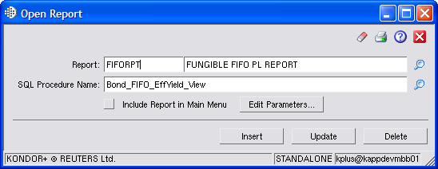

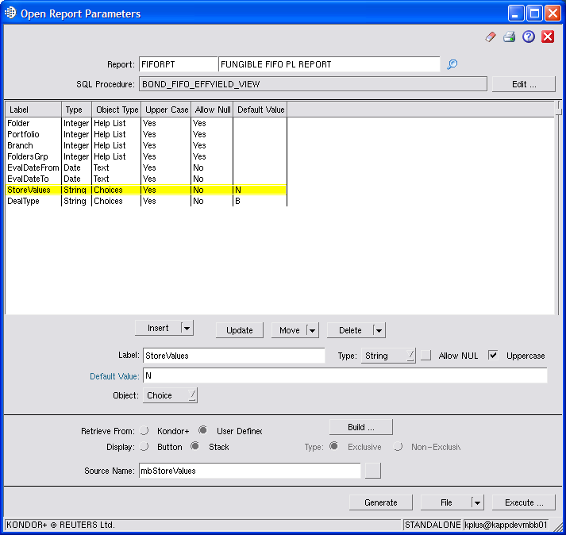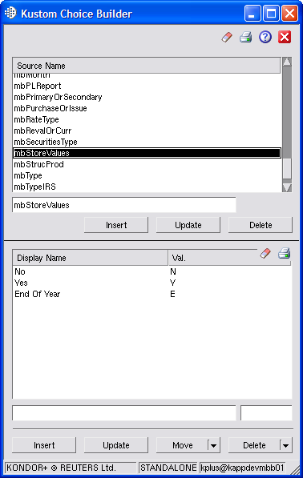
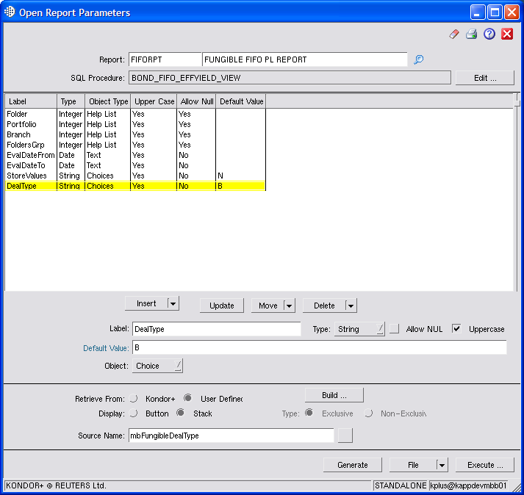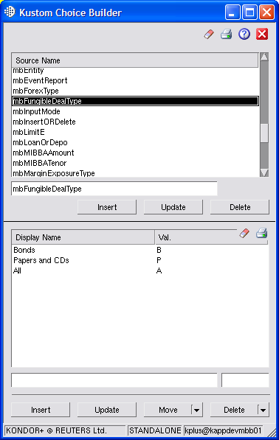

Step 3: Make sure KFS is always running.

